Spring Break Assignment: Weather Channel Watching

Due by Wednesday, March 23, 2022

Find a TV with cable that you can watch as The Weather Channel does not live stream. Here’s one streaming link I did find, but don’t know if it’s reliable (I watch TV … if you can’t access a TV, try this site or another one in REAL TIME: <https://www.livenewsnow.com/american/weather-channel.html>).

Complete these two tasks:

Log

**Keep a log of what is shown for 30 minutes the from the top or bottom of the hour** (e.g. 10:00 am to 10:30 am or 10:30 am to 11:00 am) and **write down what they cover in each segment between commercials in the table on the back of this page.**

They generally have two types of information they give. Write the topics of each segment and explain what they discussed (as though to someone not studying meteorology).

Forecast:

National (named storms, Mid-Latitude cyclones, pressure systems, air masses, jet streams … )

How do the American (GFS) and European models compare? Do they agree? Which model

does the weather channel person favor?

Regional Forecasts (what region did they focus on? Why? What are they discussing there?)

Educational Segment

What topic was explained or what “home experiment” was demonstrated … did you try it?

Reflection & Teaching

Did you understand something they said that you wouldn’t have before? Explain something you see to someone watching with you. Then reflect on how it felt to know something new. Did you find it valuable to watch the Weather Channel?

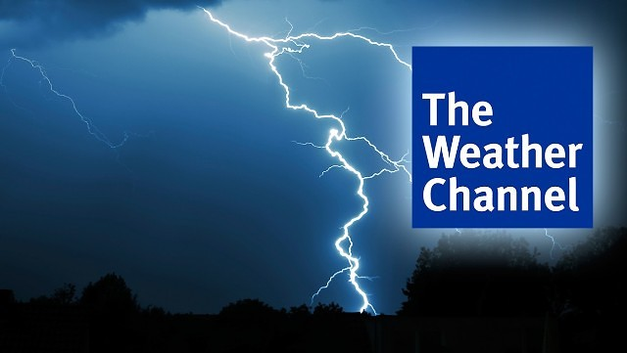

|  |  |  |  |
| --- | --- | --- | --- |
| Date: | | Location: | |
| Segment | | Information | |
| Start Time | End Time | Topic | Explanation |
|  |  |  |  |
|  |  |  |  |
|  |  |  |  |
|  |  |  |  |
|  |  |  |  |
|  |  |  |  |
|  |  |  |  |
|  |  |  |  |

