Homework Set 16: Fun with Lagrange
Due Friday, November 12, 2021
k
m
m
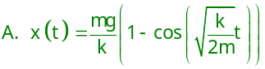1) Two equal masses are constrained by the spring-and-pulley system shown. Assume a massless pulley and a frictionless surface. Let x be the extension of the spring from its relaxed length. Derive the equations of motion by Lagrangian methods. Solve for x as a function of time with the boundary conditions 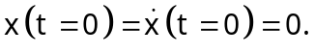 Lagrange’s Equations will give you a DE, 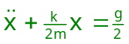for which you should guess a solution 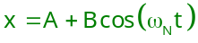.
Problems From TM5
2) 7-2 Work out Example 7.6 showing all the steps, in particular those leading to Equations 7.36 and 7.41. Explain why the sign of the acceleration cannot affect the frequency . Give an argument why the signs of 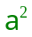 and 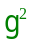 in the solution of 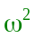 in Equation 7.42 are the same.
Write down every step in taking the derivatives of the Lagrangian … no short-cuts or you’ll miss something! Be careful about the difference between partial and full derivatives! There’s a triangle lurking in tan(θ_{e}) = (-a/g) and it does not mean that sin(θ_{e}) = (-a) … draw the triangle to find sin(θ_{e}) and cos(θ_{e})!

3) 7-3 A sphere of radius ρ is constrained to roll without slipping on the lower half of the inner surface of a hollow cylinder of inside radius R. Here, θ is the angle between the vertical and the position of the center of mass of the small sphere and φ is the angle through which the small sphere has rolled. Determine the Lagrangian function, the equation of constraint and show that Lagrange’s equations of motion, for the coordinates shown, are
θ
θ
φ
ρ
h
R
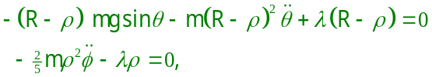

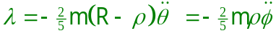where

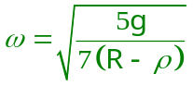
Also show that the frequency of small oscillations is
.

The energies are due to the height of the CM of the sphere and its translational (½mv²) and rotational (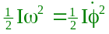) motions. The rolling constraint is that the distance moved by the center of mass is equal to the arc length it rolls
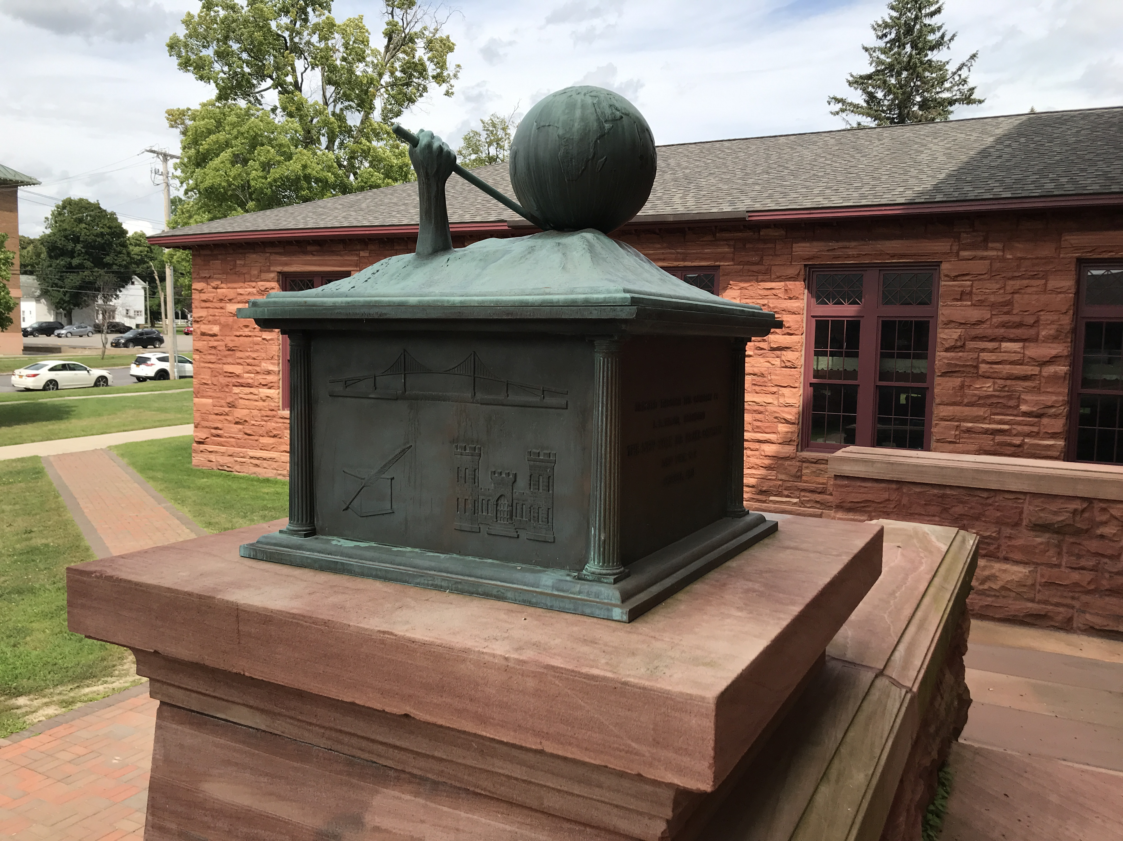

along the sphere: s_{cm} = r_{sphere}φ_{sphere}. Describe s_{cm} in terms of θ and R - ρ and use Lagrange’s equations with undetermined multipliers (TM5 Equation 7.65). For the last step, recognize that the small oscillations of the CM are expressed by 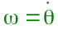. To find it, use the result of Lagrange’s equation in θ with the θ expression for λ substituted and get it in the form of 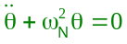.
A lever and a place to stand, Old Main, Clarkson University, Main St., Potsdam, NY

