The Arecibo Pisces-Perseus Supercluster Survey:
An Undergraduate ALFALFA Team (UAT) Project

Aileen O’Donoghue (SLU), Rebecca Koopmann (Union), Martha Haynes (Cornell), Michael Jones (Cornell), Lucas Leisman (Cornell), David Craig (WTAMU), Gregory Hallenbeck (Union), Jessica Rosenberg (GMU) and Aparna Venkatesan (USF)

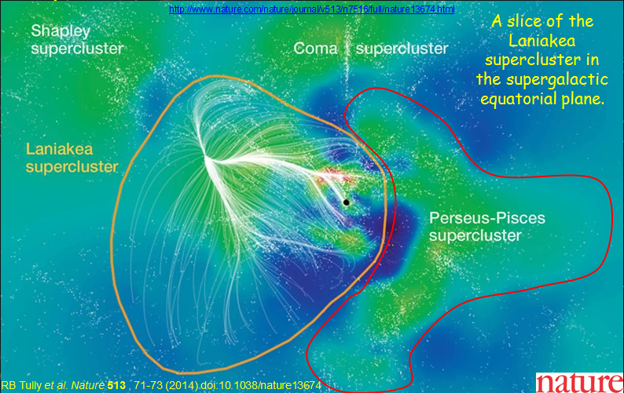
The Pisces-Perseus Supercluster
- Location, Morphology, Extent
- Why is it interesting?
Current Knowledge
- 21 cm Survey and ALFALFA
APPSS
- What we seek to learn
- Observation strategy
- Preliminary results

The Pisces-Perseus Supercluster
- Separate “watershed” from Laniakea
- Ridge: 50h-1 Mpc (Perseus to Pegasus Clusters)
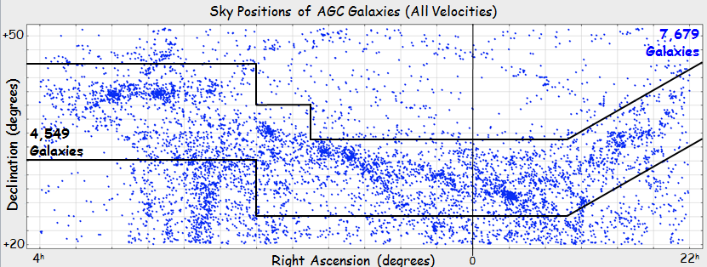

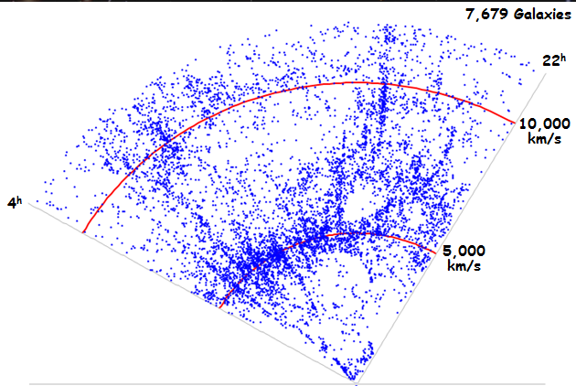
- PPS Cone: V_{helio}~ 5,000 km/s
  - Depth: 5h⁻¹– 10h⁻¹ Mpc
(parallel to sky)
  - Voids before & behind

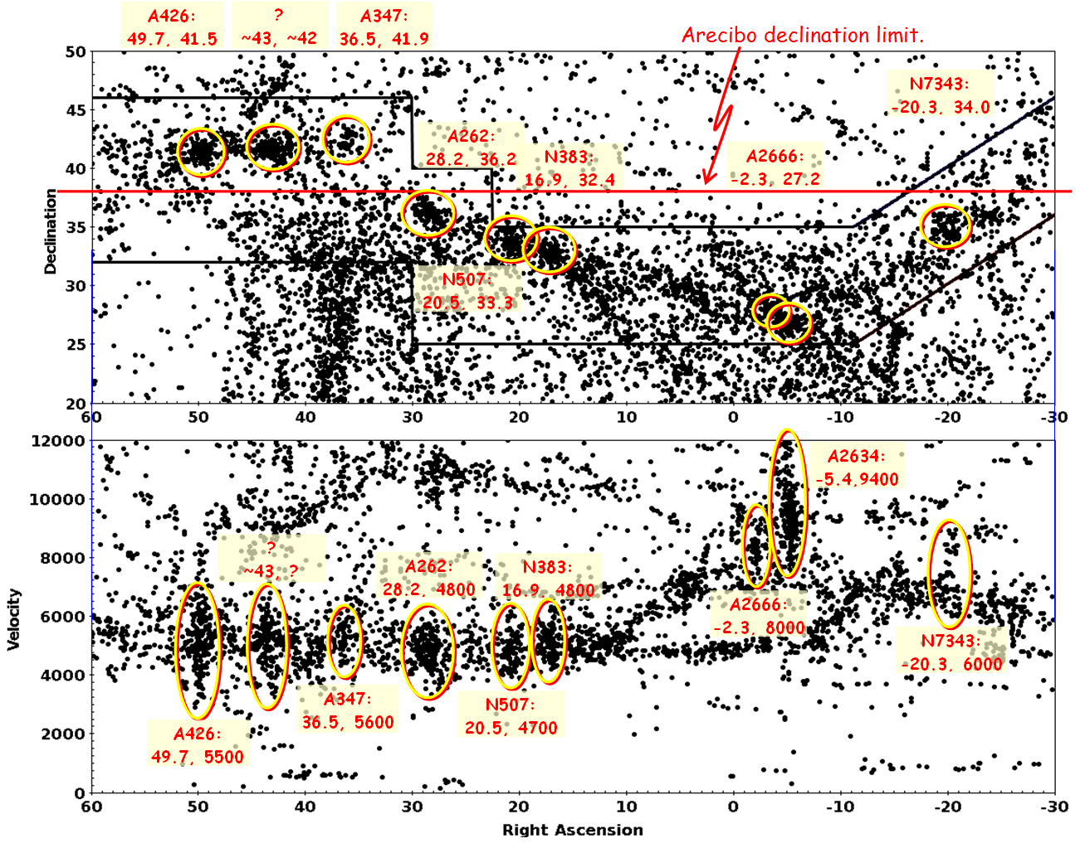
MPH diagrams from SH01 2016

ALFALFA PPS Results
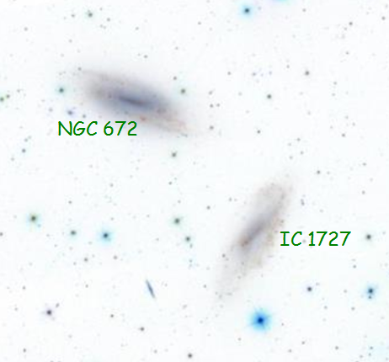
(Saintonge et al. 2008 (26° < δ < 28° , 22^{h} < α < 3^{h}))
- ALFALFA NOT going to fill in low end of mass function
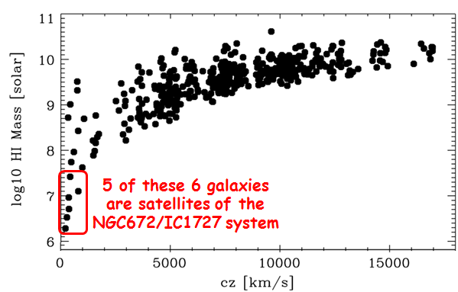
- 80% of (~2k) ALFALFA sources have M_{HI} > 10⁹M☉

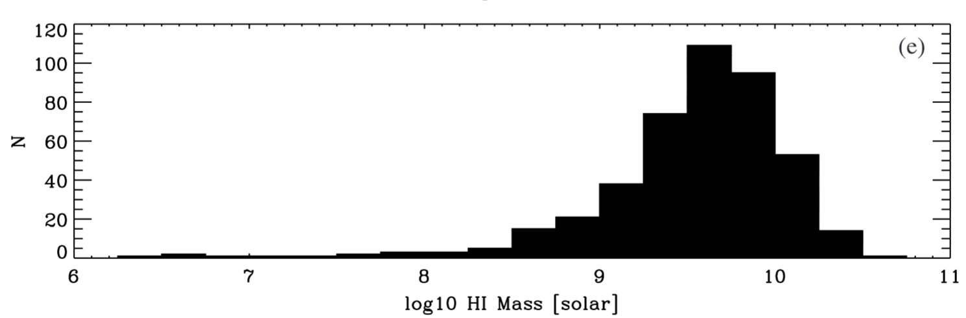

5 of these 6 galaxies are satellites of the NGC672/IC1727 system

Extending ALFALFA
- Arecibo L-Band Wide Observations
  - Seek low-mass galaxies within cz = 7,000 km/s
  - Extend low-mass end of mass function
  - Increase knowledge of PPS galaxies
    - Greater sample for morphology segregation
    - Infall velocities from Baryonic Tully-Fisher Relation
    - ΛCDM ⇒ Void should have more dwarfs
- Three Preliminary Fall Programs (A2707, A2811, A2899)
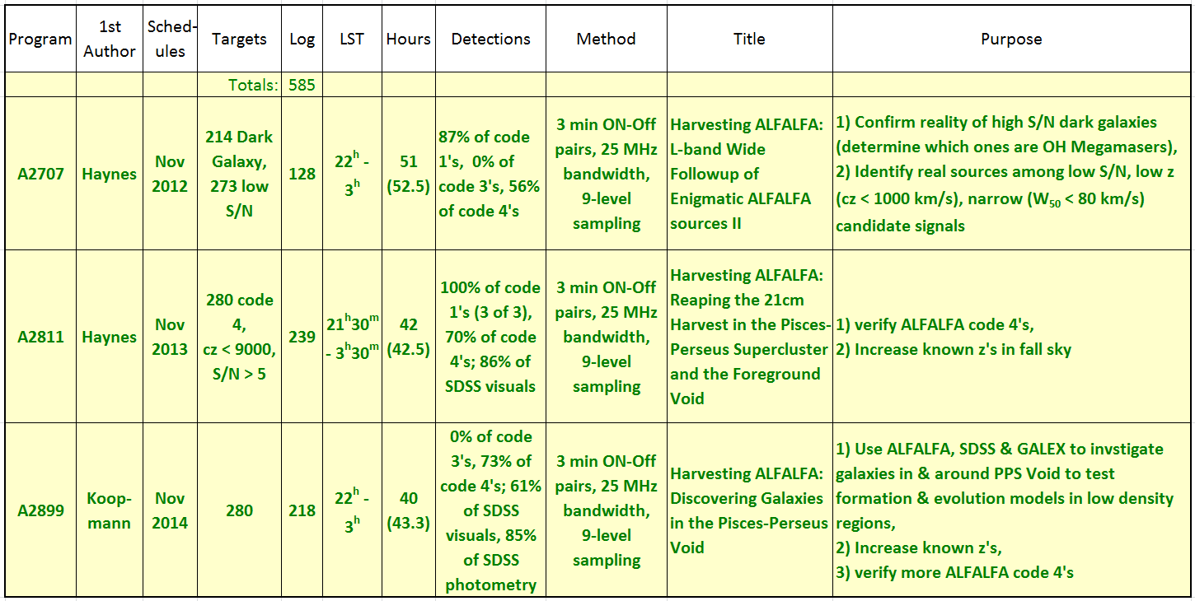

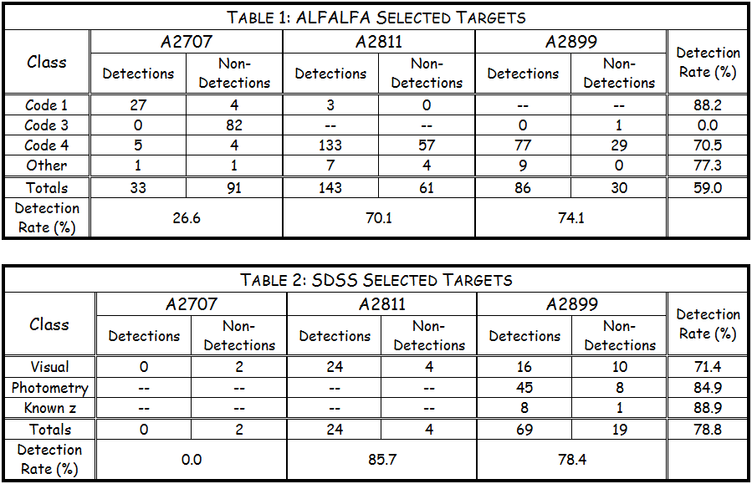

- Verifying ALFALFA detections with O.C.’s (code 1’s & 4’s)
- Identify real detections without O.C.’s (code 3’s … zero were detected)
- Test SDSS & GALEX photometry target selection
  - SDSS visuals … sources chosen visually with SDSS Navigate
  - SDSS photometry … sources chosen with SQL with magnitude ranges
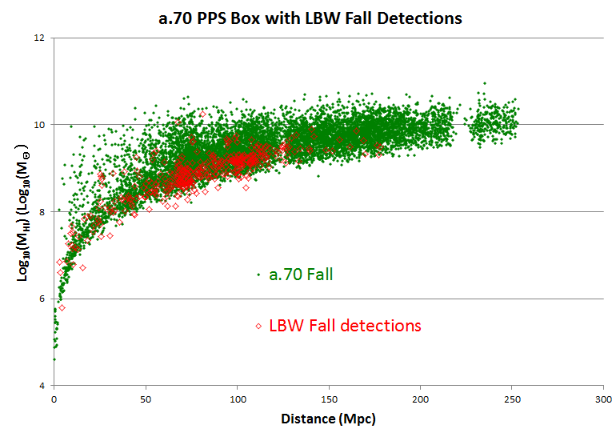
Fall LBW observations are filling in some of the lower HI masses.

APPSS
- L-Band Wide (LBW) Observations
- 250 hours along PPS Ridge
- 5-minute ON-OFF strategy
- Expect to detect M_{HI} ≥ 10⁸M☉ at dist. of PPS
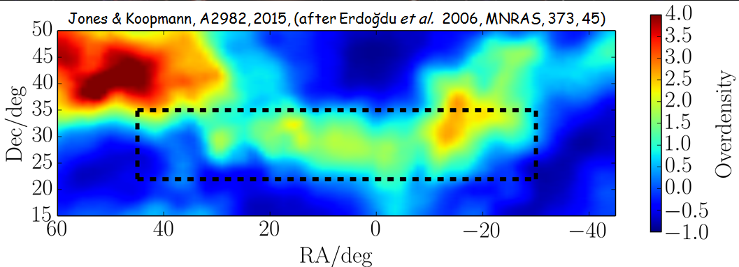

- Infall to ridge should align with line-of-sight
- M_{HI} < 10⁹M☉ ⇒ baryonic content dominated by cool gas
- Select blue disk targets from SDSS & GALEX (last summer)
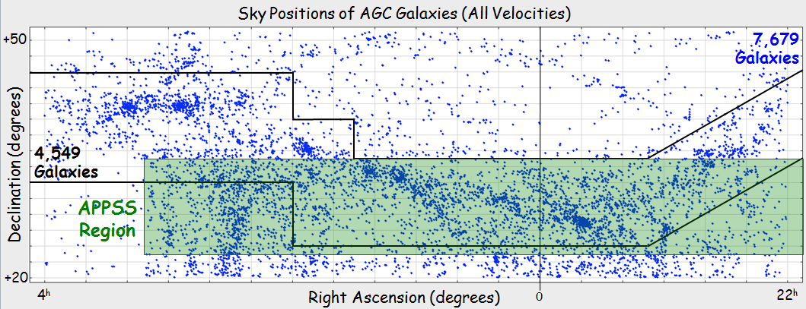

APPSS Preliminary Results
- 319 Targets (A2982)
- 173 detections
- 92 non-detections
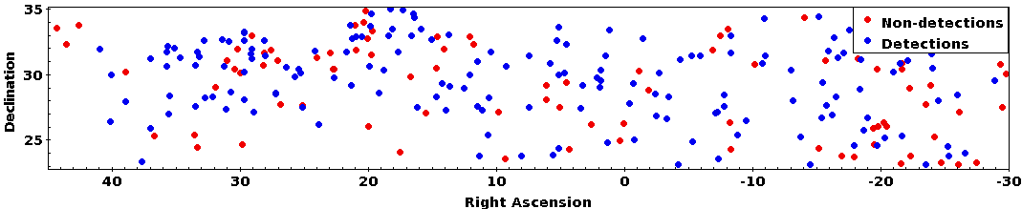
- 54 uncertain (low S/N or RFI)

