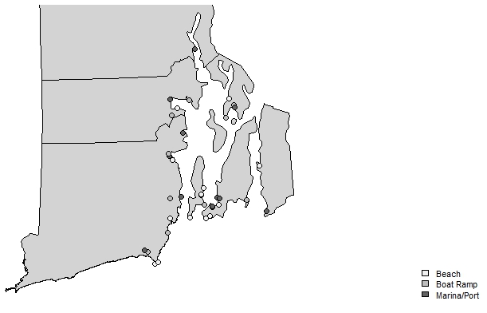
Making a Map in R
Goal: To make a map using high-resolution spatial polygon data from the web.

1. Load libraries.
library (maps)
library (RColorBrewer)
library (classInt)
library (mapdata)
library(maptools)
*note: you may get an error message, but this does not seem to affect what we're doing, so it should be fine to ignore it.

2. Download spatial polygon data from the web (high-res option)
load(url(“http://biogeo.ucdavis.edu/data/gadm2/R/USA_adm2.RData”))
##remember quotes around URL!
Note: if you look at the gadm value, you'll see that it is a Large SpatialPolygons DataFrame. Click on the blue arrow next to the name and you will see the variables that make up "gadm". One is NAME_1 which are the states of the US. For this exercise, we want to look at Rhode Island, so that is what we are going to focus on. So, we need to extract this information. To do that, enter the following code:

ri <- gadm[gadm$NAME_1 == "Rhode Island",]
Remember the comma after "Rhode Island"!

3. Plot the map.
If you want the whole state, simply:
plot(ri)

But, I want to focus on a certain area, so I am going to use latitude and longitude to set the limits for the area that I want.
plot(ri, xlim = c(-71.6, -71.2), ylim = c(41.3, 41.85))

(Sometimes, it takes a little trial and error to get the limits right. Also note that x values are longitude and y values are latitude.)

4. Add points.
To add points to this map that show study sites, save a data file with latitude and longitudes. The file I have is 2015sites.csv. I imported and renamed it as "sites" to keep things simple.

To simply show all of the sites with blue markers:
points(sites$Lon, sites$Lat, pch=19, col="blue")
?pch ##shows different types of points

However, I want to add markers the different site categories (Beach, Boat Ramp, Marina/Port). I found the following code that works well, with preset color pallets.

plotvar <- sites$Type
nclr <- 3 #number of colors
plotclr <- brewer.pal(nclr, "Greys")
## ?brewer.pal shows all of the possible color palettes
class <- classIntervals(plotvar, nclr)
##ignore error message for the purposes of this exercise
colcode <- findColours(class, plotclr)
points(sites$Lon, sites$Lat, pch=21, col="black", bg=colcode, cex=1)
##col is the color of the outline of the circle; bg = is the color of the circle itself
## pch refers to marker style, cex refers to marker size

5. Add a legend.
legend("bottomright", legend=c("Beach", "Boat Ramp", "Marina/Port"), fill = attr(colcode, "palette"), cex=0.7, bty = "n")

6. I have found that you can also plot maps right from Google Maps. There are a lot of options for this. Here is one example:
library(RgoogleMaps)
lat <- c(41.4, 41.8)
lon <- c(-71.5, -71.2)
center = c(mean(lat), mean(lon))
zoom <- 10
termap <- GetMap (center = center, zoom = zoom, maptype = "terrain", destfile = "RIterrain.png") ## will save file in project folder if you have designated one in R Studio

Sources and Resources
http://www.milanor.net/blog/?p=594
http://www.r-bloggers.com/mapping-points/
http://www.gadm.org/download

