Project #1 Data due: Wed. 2/9/22
Robin Lock 2/4/22 Report due: Wed. 2/16/22
Value: 25 Points
Correlation & Simple Linear Regression
Applied to a Virtual Used Car Lot

SITUATION:
Suppose that you are interested in purchasing a used car. How much should you expect to pay? Obviously the price will depend on the type of car you get (the model) and how much it's been used. For this project you will investigate how the price might depend on the age (in years with 2020=2 year old).

DATA SOURCE:
To get a sample lots of cars, go to the webpage http://myslu.stlawu.edu/~clee/dataset/autotrader/ which will obtain data from listings at autotrader.com (link is in Sakai). Pick a car make and model (e.g. Honda Accord) and a zip code to sample from. You eventually want a sample of 50 used cars, so ask for 60 or so to start in case you need to do some pruning. Also, choose a name for the dataset with a .csv extension.
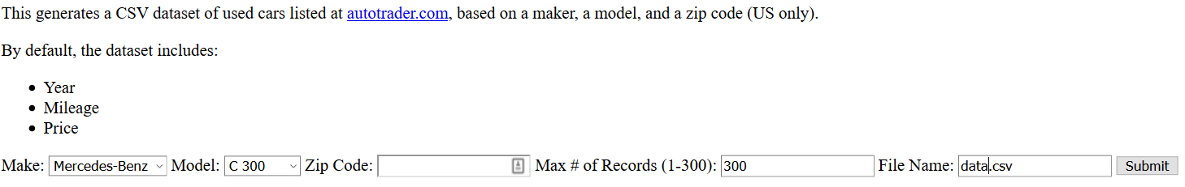
If you have trouble getting a large enough sample, try a different zip code (e.g. 02045 will sample near Boston). After saving your data, check the spreadsheet to see if some cases should be deleted (e.g. if a car is actually new, has a price of zero, or has been driven very few miles) otherwise delete cases at random to get to a sample of size 50 (ie. 51 rows including the header row with variable names). The dataset should have columns for year, price (in $1,000’s) and mileage (in 1,000’s). You should add a variable called age which is 2022-year. Please do that in the downloaded .csv spreadsheet. Note: You will need to upload the .csv file to a folder in RStudio before you can read it into an R session.

REPORT:
- Start with an introduction that identifies your car model, zip code (with town/city, if known) for the sample. For this assignment you will be looking only at a simple linear model using age to predict price. A later assignment will use fancier models involving both age and mileage.
- Use R to directly compute each of the following summary statistics. Include both the values and the R commands you use to find them. Please label the results clearly.
$\overline{x}$, s_{x}, $\overline{y}$, s_{y,}, SSX, SSXY, SSY (same as SSTotal), SSModel, SSE
- Show how to calculate the least squares regression line that best fits your data using the values generated in (2) – you can confirm the result with R. Interpret (in context) what the slope estimate tells you about prices and ages of your used car model.
- Again, using the values in (2) above, show how to estimate the standard deviation of the error term for your model.
- Produce three plots and comment on what each plot tells you about the regression conditions for your data.
- Scatterplot with the regression line shown on it.
- Residuals vs. fits plot
- Normal quantile plot of residuals

- Find the car in your sample with the largest residual (in magnitude – positive or negative). For that car, use R to find its studentized residual, leverage, and Cook’s distance. Would any of these values be considered unusual? Specify the specific (numeric) criteria you use for each measure.
- Compute and interpret a 90% confidence interval for the slope of your model (show an explicit calculation – not just a single R command).
- Test the strength of the linear relationship between your variables using each of the three methods discussed in class. Include hypotheses for each test. You may calculate the relevant test statistic or find it in computer output (but don’t expect me to find it for you!). Indicate the reference distribution (t or F including degrees of freedom) for each test. One conclusion should suffice for all the tests.
- test for correlation
- test for slope
- ANOVA for regression
- Compute the value of $r^{2}$ two ways -- as the square of the correlation and using values in the ANOVA table Write a sentence that interprets the result (in context) as a percentage.
- Suppose that you are interested in purchasing car of this model that is three years old (age=3). Show how to calculate each of the following quantities - by formula with numbers substituted! You may confirm the values with R. Write sentences that carefully interpret each of the intervals (in terms of car prices).
- predicted value for the price
- 90% confidence interval for the mean price at this age.
- 90% prediction interval for the price of an individual car at this age
- According to your fitted linear model, is there an age at which the car should be free? If so, find this age and comment on what the "free car" phenomenon says about the appropriateness of your model.

Technology note: Your project report should be done with RMarkdown so that graphs, R commands, and output appear along with interpretations. Put as much as you can in the RMarkdown file. However, you do not have to typeset calculations – feel free to add some space and write them in by hand. If you want to get fancy, try typing calculation using Latex in the RMarkdown or adding them later with the equation editor in Word. Turn in a hard copy version of the final report.

Collaboration rules: As with HW #1 you may consult with up to two classmates and please identify them in your report.

Due dates:

By this Wednesday (2/9): Please send me a copy of the .csv file with your data via the Assignment in Sakai. Be sure that the variables are labeled exactly as year, price, mileage, and age in the top row – and that you have exactly 50 data cases (so 51 rows in the spreadsheet). Check this carefully!

By next Wednesday (9/16): Turn in a written copy of your report.

