Project 1 - Key
cars=cars=read.csv("~/My Dropbox/Robin/Courses/!Stat213/Data/Project1/Akingba.csv")
agestar=4

#2. Summary statistics
$\overline{age}=6.09$, $s_{age}=3.7$, $\overline{price}=10.43$, $s_{price}=3.83$
$SSX=438.7$, $SSY=469.2$, $SSXY=-400.1$, $SSModel=364.8$, $SSE=104.4$

#3. Least squares line
${\hat{β}}_{1}=\frac{-400.1}{438.7}=-0.912$ and ${\hat{β}}_{0}=10.5+-0.912*6.1=15.98$ so $\overset{ˆ}{price}=15.98+-0.912*age$

4. Std. dev of error
$${\hat{σ}}_{ϵ}=\sqrt{\frac{104.4}{33-2}}=\sqrt{3.37}=1.84$$

#5 & #6 Scatterplot with regression line & residual plots
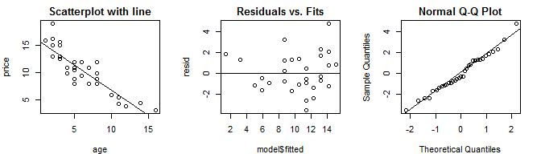

#7 Largest residual
Case #25 has residual=4.74 with studentized residual=3, Hi =0.068 and Cook's D=0.263 Criteria for leverage are 4/n=0.121 (mild) and 6/n=0.182 (severe)

#8 CI for slope
$$-0.912±1.696*0.088=(-1.06,-0.763)$$

#9. R-squared
$$r^{2}=(-0.882)^{2}=\frac{364.8}{469.2}=0.778$$

#10 Three tests for a relationship
$t=\frac{-0.912}{0.088}=\frac{-0.882\sqrt{33-2}}{\sqrt{1-(-{0.882}^{2})}}=-10.409$ and $F=\frac{364.8}{3.4}=108.35$ with p-value=1.219491210^{-11}

#11 Prediction for age=4 we have $\overset{ˆ}{price}=12.33$
$$CI=12.33±1.696*1.835\sqrt{\frac{1}{33}+\frac{(4-6.09)^{2}}{438.7272727}}=(11.71,12.96)$$
$$PI=(9.16,15.51)$$

12 Free car is at age=17.5

